CSP2132 Enterprise Data

**Assessment 2:  Design Task - Information storage and management**

Contents

Executive Summary 1

Storage Requirements 2

1. File Server and disks 2

2. Web Server FTP 3

3. Redundancy 4

4. SAN LUNs 6

Virtualisation Requirements 7

1. Hypervisor Server 7

2. Application and Web Servers 7

3. Hypervisor Datastore 9

4. Allocated Storage 10

Conclusion 10

# Executive Summary

For the assignment given, the storage solution has been done along with virtualization work. This solution is implemented using Windows server 2019 with VMware Esxi. Firstly, the storage part was configured based on the requirements, and then following the storage, the virtualisation solution has been done. First part i.e. storage configuration shows the process of performing requirements given. Then the second part i.e. virtualizations shows the process of performing requirements given under the virtualization category.

# Storage Requirements

## File Server and disks

The initial stage starts from the installation of Windows server 2019 in VMWare. The following screenshot elucidates the installation of Windows server on VMWare. I have used Windows server 2019 standard version for the implementation part.

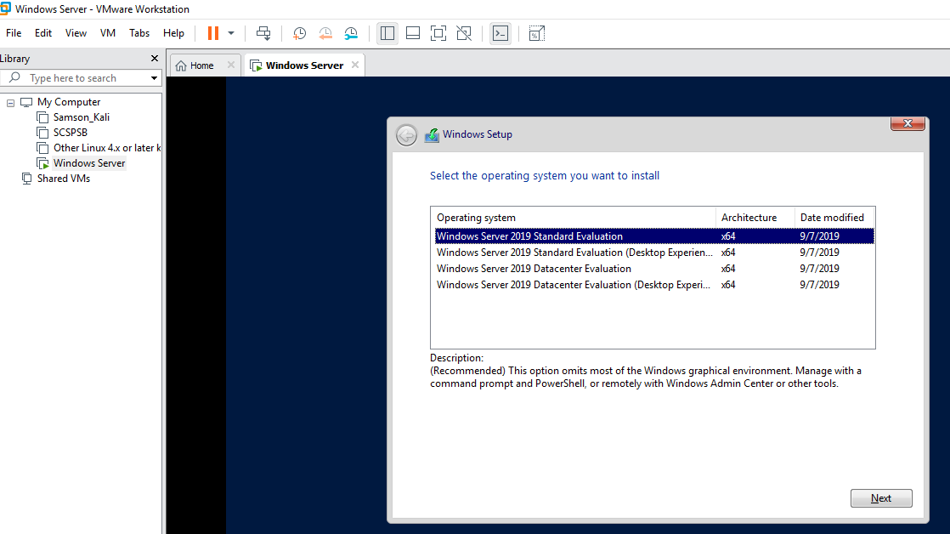

Screenshot 1 OS installation

Once, the installation is done, I logged in, then started to add the features under the add roles, and features menu, which can be found the following screenshot.

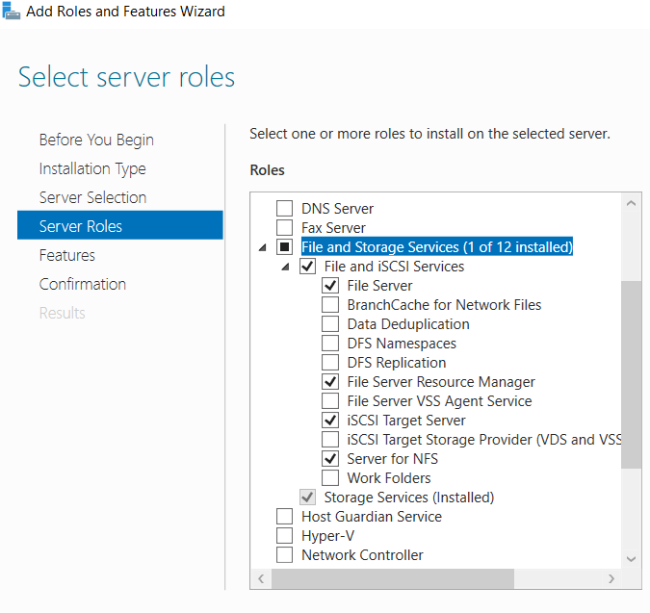

Screenshot 2 Enabling Files, and Storage services

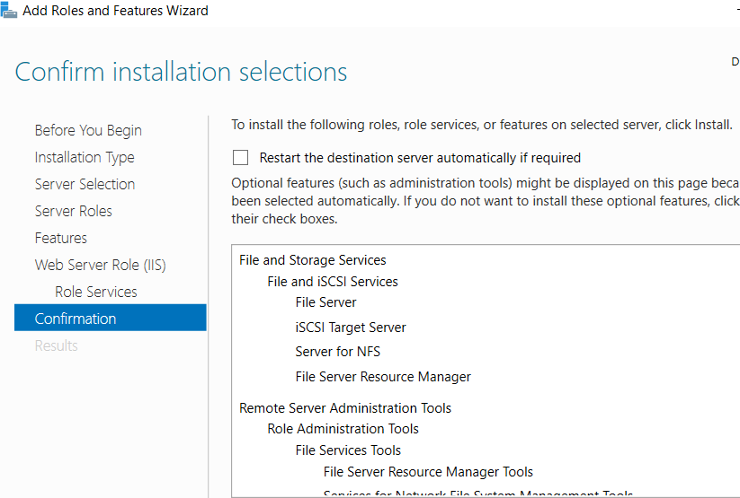

Screenshot 3 Confirming the installation

## Web Server FTP

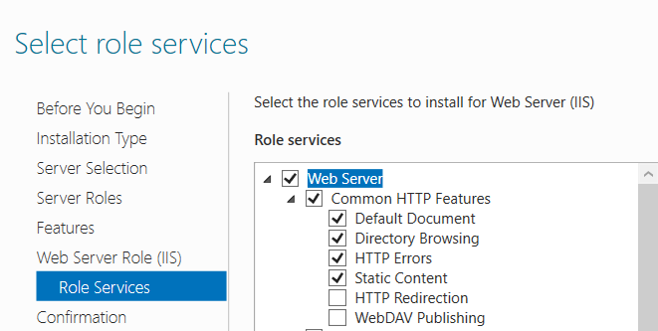

Screenshot Enabling web server

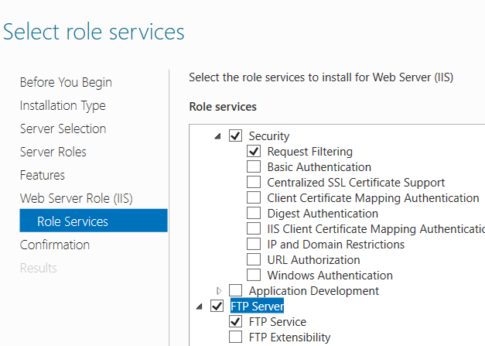

Screenshot Enabling FTP service

Above given screenshots shows the activation of FTP, and web services in Windows server.

## Redundancy

The following screenshots shows the creation of storage pool. Due to my system hardware issues I have configured the pool only for 253 GB.

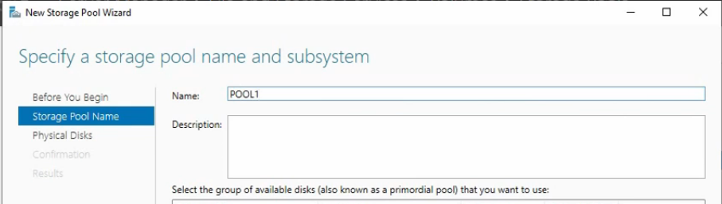

Screenshot POOL Creation

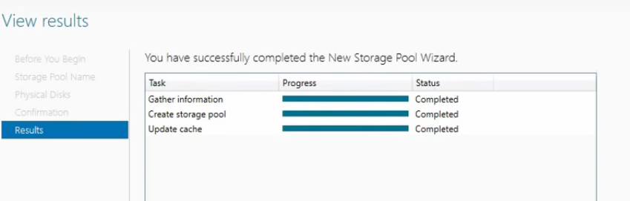

Screenshot POOL created successfully

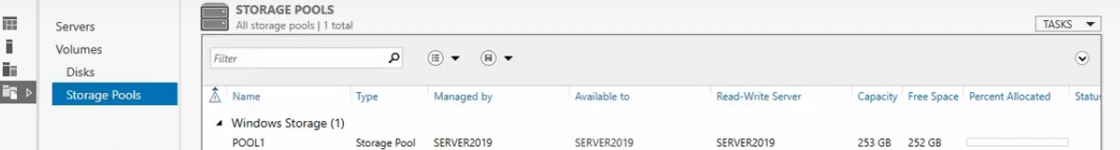

Screenshot POOL overview

Once, the storage pool has been done, then the virtual hard disk has been created. The following screenshots shows the creation of virtual hard disk from the storage pool.

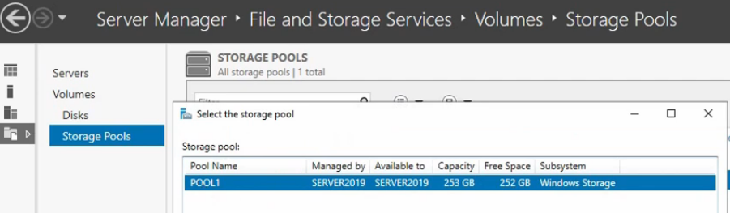

Screenshot Selecting the POOL to create virtual hard disk

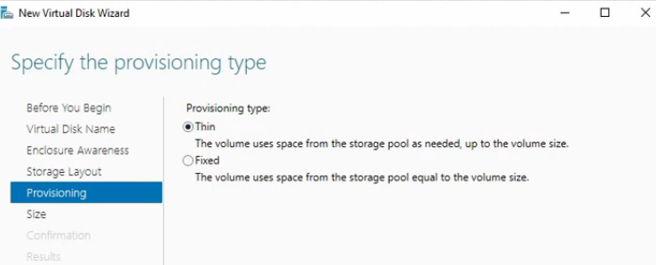

Screenshot Selecting the storage layout type as Thin

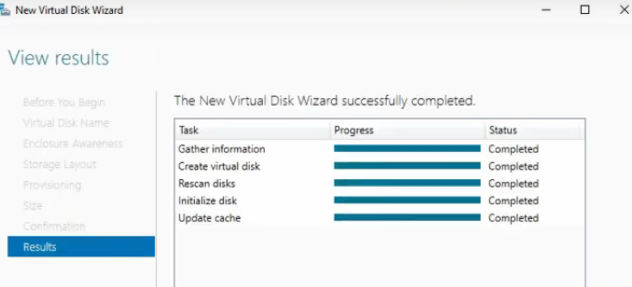

Screenshot Hard Disk Created Successfully

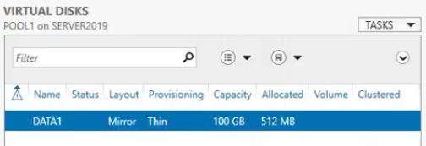

Screenshot Final result

## SAN LUNs

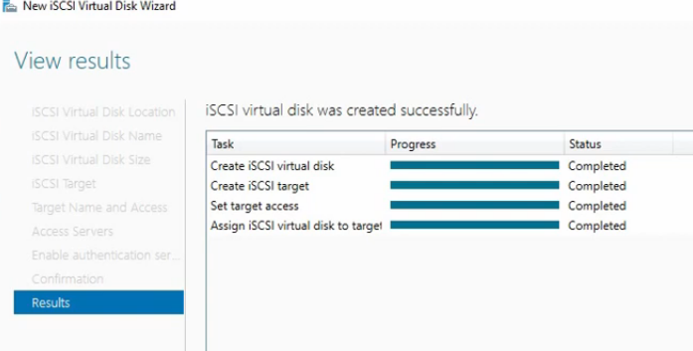

# Virtualisation Requirements

## Hypervisor Server

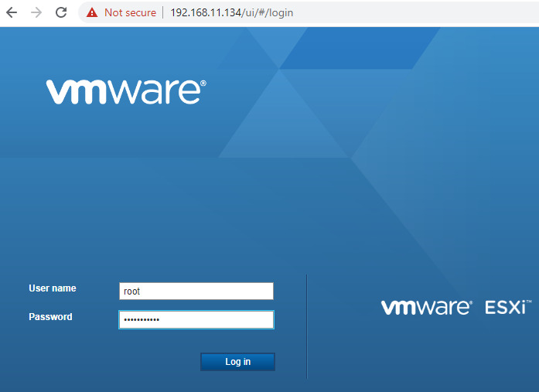

Screenshot 13 ESxi installation

Once the storage configuration is done, I have installed VMWare ESxi over the VM. Above screenshot shows the homepage of the VMWare ESxi.

## Application and Web Servers

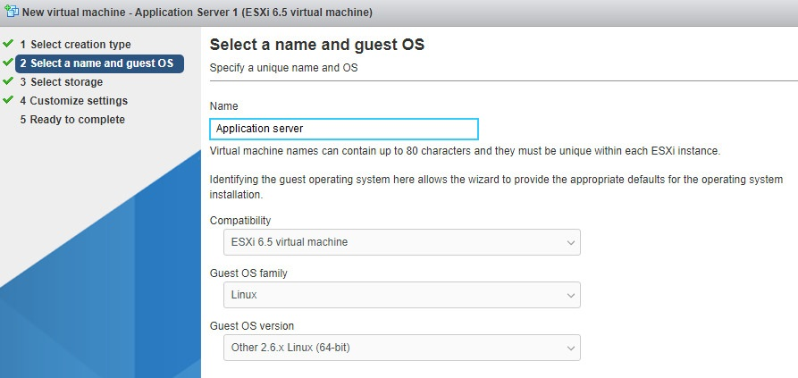

Screenshot 14 Installing application server

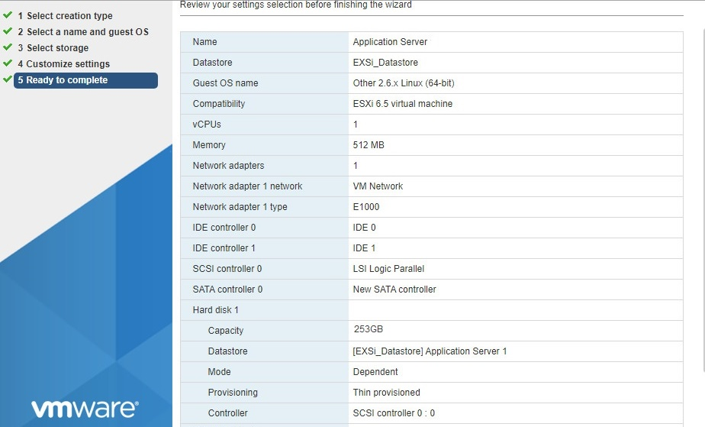

Screenshot 15 Finishing the installation

Using the same method I have installed the second application server also. The following screenshot shows the running of two application servers at same time.

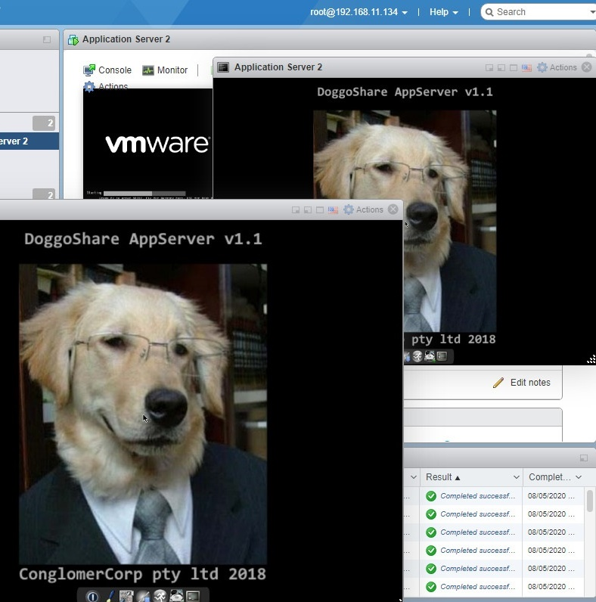

Screenshot 16 running two application servers at same time

## Hypervisor Datastore

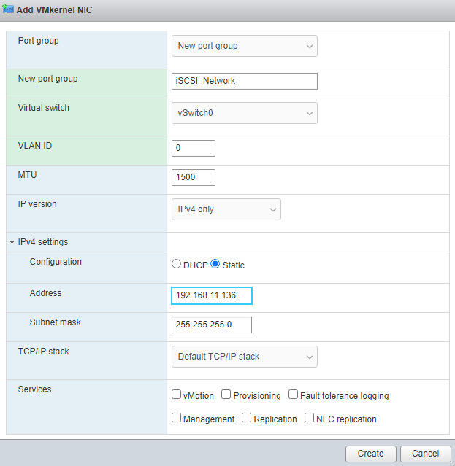

Screenshot 17 iSCI interface configurations

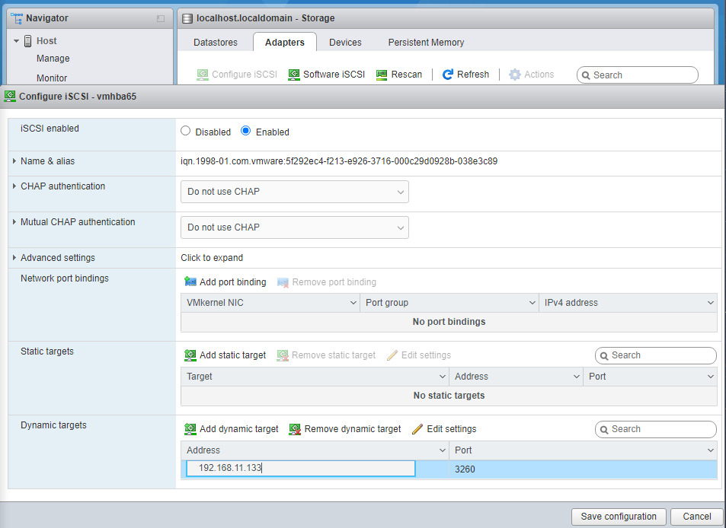

Screenshot 18 iSCI interface configuration cont..

## Allocated Storage

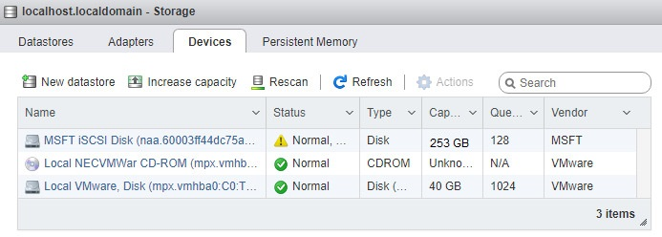

Screenshot 19 Allocated storage

Due to my insufficient hardware and system configuration the allocated space is configured less than the size mentioned in the requirements.

# Conclusion

During the implementation for this assignment I have encountered several technical issues since my system hardware is not enough for the implementation. Due to that I was not able to deliver the high efficient solution.